Introduction to heating your home
In this fact sheet:
- Temperature and moisture
- Radiant vs convective heat
- Your main heat source
- Heating bedrooms
- Combining water and space heating
- Choosing the right heater

When it comes to being healthy in winter, one of the most important things you can do is have a warm home. The World Health Organisation tells us that, when occupied, your bedroom should be a minimum of 16°C and your living room a minimum of 18°C. If you are an older adult, or there are young children, or you are sick, then the minimum recommended temperatures increase to 18°C in the bedroom and 21°C in the room.
This means that even if your home is designed to retain as much heat as possible, you may need to heat your home to ensure your family is healthy.
Very few New Zealand homes are consistently heated to these levels. One of the reasons, of course, is that our poorly insulated, draughty homes are really hard to heat! That’s why we recommend you increase your insulation step in any renovation. But, unless you have a super dooper, heavily insulated, energy efficient eco home, in most of New Zealand you are still going to need to heat.

Temperature and moisture
There’s a strong link between temperatures in your home and moisture levels. If you have cold temperatures in your house, then the air can hold less moisture and your relative humidity levels increase. The moisture in cold air naturally settles on cold surfaces such as un-insulated walls, ceilings and windows as condensation. This creates the perfect conditions for growing mould – the root of many respiratory illness and asthma, as well some allergies and some forms of gastroenteritis.

Radiant vs convective heat
There are two main types of heating devices.
- Radiant heaters (e.g. the sun, a wood burner, a bar heater, a flued gas heater)
- Convective heaters (e.g. a heat pump, oil column heater, wall-mounted panel heaters, night store heaters or a pellet burner).
Some people prefer radiant heat. You sit closer to the heater or fire and you get toasty warm. Some people prefer convective heat, which creates background warmth. Either works well - it’s your personal choice what you like.

Your main heat source
We generally recommend a large heat source to complement your well-insulated home – a low emission wood burner, a pellet burner or an Energy Star rated heat pump. All of these methods are efficient ways to heat your home. However, without insulation, a large amount of the heat will be heating the planet (literally) rather than your house.
Generally wood burners and heat pumps have the lowest running costs – though some people find that they heat their home much more with a heat pump and their heating bills increase.
From a sustainability perspective, low emission wood burners and pellet burners are generally regarded as the best option. While wood burners work even when there is a power cut, pellet burners won’t unless you have a backup battery installed.

Heating bedrooms
In some houses, your main heat source will be enough to keep you warm; in others, you might need secondary heating or a heat transfer system to help move the warm air to the bedrooms.

Heat transfer systems
Heat transfer systems are ducting installed into your ceiling, or between floors, which moves heat from one room to another. They are not a ventilation system or a heating system – they use the heat that is produced by your main heater – e.g. your wood or pellet burner. Heat transfer systems are most commonly used to move heat from the living spaces to the bedrooms. You can buy DIY installation kits from your local hardware store, or get them professionally installed.
Tips for heat transfer systems
Heat transfer systems only work well if there is spare heat to move around. If you are under-heating your living area, there won’t be spare heat to move to the bedrooms.
Hot air rises, so you can only transfer heat from downstairs to upstairs
It is easier to transfer heat over short distances. As the air moves through the ducting from one room to the next, it cools down - if it has to go too far, it won’t be very warm when it arrives.
Transfer the heat to where you want it. If you want to warm your bedroom, make sure that the outlet is in the bedroom – preferably in the middle of the room. Don’t transfer heat to a hallway outside a number of bedrooms – it won’t make much difference to how warm your bedrooms are if you do.
Fewer outlets are better than a lot. Transfer the heat to only 1 or 2 rooms. If you want to warm more rooms, you will probably need to consider having a second heating device.
Get a heat transfer system with a thermostat – that way you can set the temperature at which you want it to start transferring heat (Beacon recommends a minimum of 18 degrees in your main living area) and it will siphon off the excess heat without you needing to think about it.
Make sure the fan size is sufficient. If you have several outlets, you might need a bigger fan than if you only have one.

Secondary heating
For many people, secondary, or spot heating, will be needed as well as your major heat source, and different spaces will need to be heated in different ways.
Secondary heating is generally a portable or fixed electric or gas heater. Heaters shouldn’t be placed under a window – all the heat will go out it
Combined water and space heating
Both wood burners and pellet burners are able to have wetback water heaters installed with them to heat your hot water. This generally works best where your hot water cylinder is close to the burner (within about 5 metres); otherwise plumbing costs can get high. If you live in an urban area, make sure that your burner will still meet the clean air standards set out by the Ministry for the Environment – visit http://www.mfe.govt.nz to find a list of authorised wood and pellet burners which meet National Environmental Standards.
Tips for efficient heating
Put heaters away from windows so they heat the room more effectively.
Turn off heaters in rooms you’re not using.
It’s worth reading your heater’s manual so you can use your heating system as efficiently as possible.
Use the thermostat and timer on your heaters so they only come on when you need them and automatically switch off when they reach a certain temperature
Use a heat transfer system to move heat from a central main heater to bedrooms.
Use smaller spot heaters to warm bedrooms.
Don’t heat hallways; the heat will not get into bedrooms.

Choosing the right heater
Choosing a good heater is dependent on many factors, including:
- Upfront cost / ongoing costs. The emphasis should always be on the combined costs – particularly as energy prices only go up, not down
- Size of the space you are heating
- Levels of insulation
- Amount of temperature control needed
- Your personal preferences and aesthetics
- Cheap fuel sources (e.g. firewood)
The table over the page lists heaters roughly in order of recommendation. The actual order needs to take into account the preferences and needs of the people in the home.
Heater Type | Pros | Cons | Good For
Solar  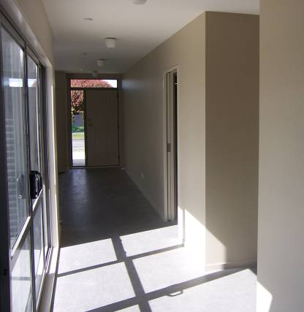 | - Free, renewable, no greenhouse pollution. | - Requires thought in design process  - Not always available on the colder days  - Only heats during the daytime.  - Generally insufficient to heat a whole home unless it is very heavily insulated (well beyond Building Code) and carefully designed. | - A well chosen section and a well designed building with good year round sun.  - New houses and major extensions.
Enclosed wood burner  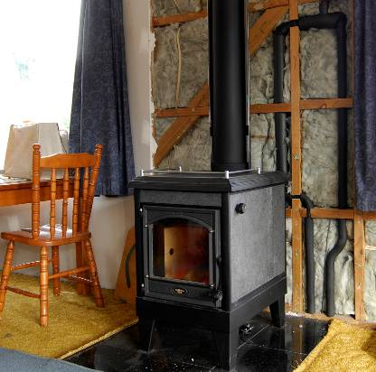 | - Near-carbon neutral and renewable heating,  - Cheapest heater to run,  - Works even in a power cut.  - Can be combined with a wetback to provide hot water heating.  - Wide range of models available (8kW – 30 kW) means most houses can be heated by a wood burner. | - Generally are large heaters – at least 8 kW which can result in hot spots if the heat is not moved around though open doors or through a heat transfer system.  - Does require a dry space for storing wood. Stacking, chopping and moving wood are required.  - Older models and those burning damp wood can contribute to air pollution. | - Heating large areas.  - Where wood is cheap or freely available.  - Areas with poor electricity security.
Pellet burner  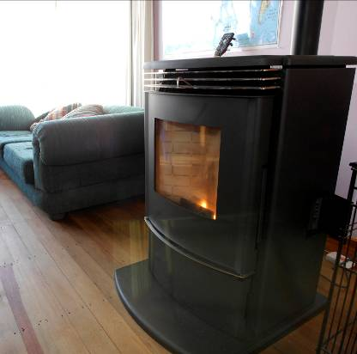 | - Very clean burning  - Easy fuel source to handle and control  - Can heat very large spaces.  - Carbon neutral and a renewable heating type.  - By buying bags of pellets, heating costs can be managed on a weekly budget, although pellets are cheaper to buy in bulk.  - A fairly cheap way to heat.  - Can be combined with a wetback to provide hot water heating also.  - Are controlled by thermostat - some models have timers and remote controls to tailor operation | - Requires electricity to run.  - A limited range of wood pellet suppliers.  - Convective heat rather than the radiant heat of a wood burner.  - To warm whole house, heat needs to be moved around through open doors or a heat transfer system.  - Smaller output than wood burners (mostly 8kW -15kW) means large houses may find more than one pellet burner is required. | - Heating large areas
Heat pump  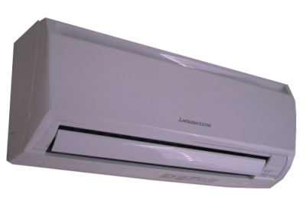  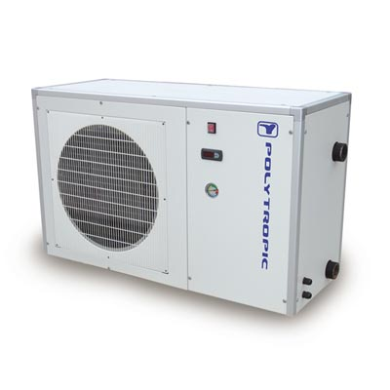 | - More efficient than other electric heaters and very efficient models are now available.  - Highly controllable - has a thermostat setting and, in most models, a timer for switching on and off to suit needs.  - Able to act as an air filter as well.  - A safe form of heating (fewer chances of accidental burns or fires than other types of heater) | - Efficiency reduced when outside temperatures drop below 7°C which increases running costs.  - Can stop working completely in deep snow or in very cold, humid conditions  - Given they are essentially a one room heater, they are expensive to install.  - Can be noisy (particularly for neighbours).  - Running costs, if used for cooling in summer, can negate any energy savings from winter.  - Heating costs can be higher than expected for those who have changed from a wood burner as their main heater or who have increased the amount that they heat.  - Must be installed by a qualified installer.  - Completely reliant on electricity supply | - Room-specific heating.  - Areas (such as Christchurch) where there are severe air pollution problems.  - Houses with small sections/limited room for storing wood or pellets.  - A good money saving option for people who are currently heating a lot with electric heaters.
Flued gas  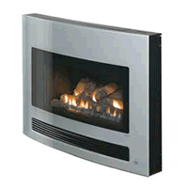 | - Fast.  - Responsive.  - A good use of gas (compared with burning it to make electricity in power stations). | - Unknown future in terms of supply. Not a renewable resource.  - Gas prices are now high, and line /bottle hire charges mean it’s expensive if you are only using gas for heating.  - Generally only will heat one room. | - A range of space sizes.  - A good option if the house is already hooked up to the gas supply.
Central heating  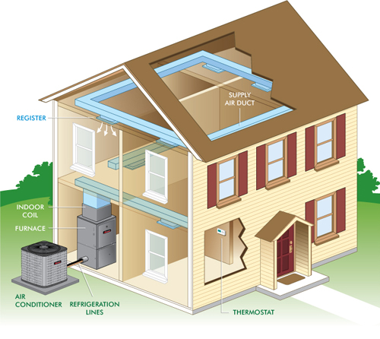 | - A range of fuel types possible (e.g. heat pumps, gas, diesel, wood pellet).  - Will heat the entire home to an even temperature.  - Can be timed to come on and temperature set using a thermostat. | - Not easy to retrofit into existing homes  - Heat losses occur from ducting under the floor or in the ceiling. | - Highly controlled heating.  - If the homeowner is always at home
Central heating with radiators  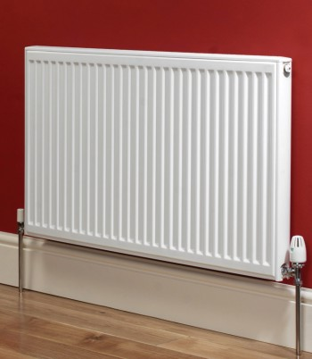 | - A range of fuel types possible (e.g. electric, gas, wood, pellet, solar hot water).  - Controllable with thermostat and timer settings (some cover 7 days to allow weekend and weekday settings). | - Still expensive to retrofit in this country.  - Radiators can take up space in the house. | - Heats the whole house in a controlled way.
Electric convection  (e.g. oil column, fan)  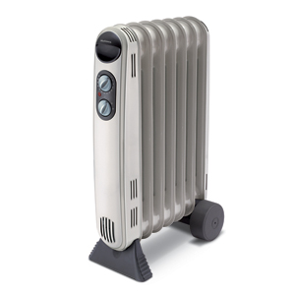 | - Quiet.  - Can be operated on off-peak rates.  - Generally has a thermostat and some have a timer setting. | - Only good for smaller spaces.  - Provides indirect heat. | - Background heating of bedrooms.
Electric resistive (bar)  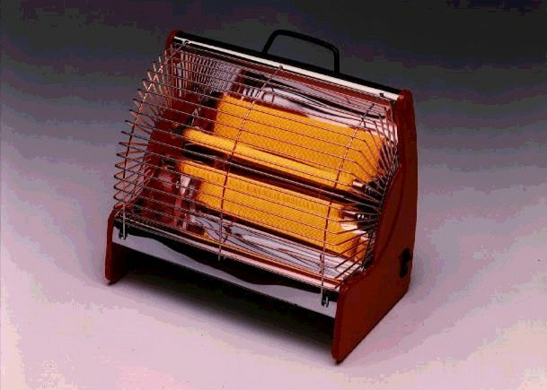 | - Highly responsive.  - Provides more direct heat – a good single person heater. | - Fire risk.  - Not very adjustable.  - Heats a person, not a space. | - Houses which have very good insulation, and where spot heating of a person is desired.
Under-floor heating  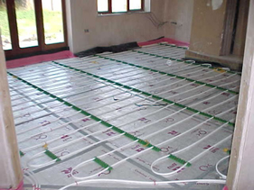 | - A range of fuel types possible (e.g. electric, gas, diesel).  - Controllable with thermostat and timer settings (some with room-by-room control). | - Not possible to retrofit to existing homes without substantial renovation.  - Although fairly maintenance free, expensive repairs if something does go wrong.  - Not very responsive – takes time for the heat to build up.  - Carpeting over heated floor will trap heat under-floor. | - If the homeowner is always at home.  - Houses with very good under-floor insulation.

To find out more, Consumer New Zealand produces a useful and comprehensive range of information on types of heating devices and recommendations on brands of heaters. It also includes a heater size calculator so you can work out what size heater you need for a room. Visit www.consumer.org.nz
Unflued gas heaters: don’t use them!
These heaters, either the portable LPG ones or fixed LPG or piped gas heaters, are considered to be a real bugbear. They’re banned in most developed countries, for good reason.
They emit gases into the air of your home:
Nitrogen dioxide
Carbon dioxide
Carbon monoxide
These gases are bad for your health, particularly for people with asthma or respiratory illness. That’s why the Ministry of Health issues warnings to only use these heaters in well-ventilated spaces.
Unflued gas heaters produce about a litre of moisture into the air for each hour of use. Moisture brings condensation, mould and mildew, which are also bad for your health. A common response to the dampness is to run a dehumidifier as well. Dehumidifiers are expensive to run – they cost between $0.14-$0.42 per litre of water removed. This creates a hidden cost of keeping warm.
With recent increases in gas prices, unflued gas heaters are actually a more expensive form of heating than most other methods.
If you have one, don’t run it, and we urge you to take it to the tip or scrap metal recycling centre.

For more information:
- See Fact sheets on
  - Heating: Unflued gas heating
  - Keeping heat in: Overview
  - Whole house mechanical ventilation systems
- Visit the Consumer New Zealand website for comparative information on heaters and heating costs: http://www.consumer.org.nz
- Visit the Smarter Homes website for more information on heating: http://www.smarterhomes.org.nz/energy/heating

