Keeping cool in summer
In this fact sheet:
- Keeping the sun out
- Creating air movement
- Active cooling

Getting the ventilation right in your home can have a big impact on temperature – at 50% relative humidity a ventilation rate of 0.5 m/sec feels like a drop of 3 degrees in temperature.
There is a lot you can do to cool your home before considering installing active or mechanical cooling (such as air conditioning or whole house ventilation systems). Passive cooling incorporates passive solar design (see Fact sheet on ‘Passive solar design’) and simple actions you can take to ventilate and shade your home. The key is designing to prevent overheating in the first place by keeping the sun out during the hot parts of the summer day and creating air movement (passive ventilation) which allows the house to be well ventilated even when the occupants are out.

Keeping the sun out
Keeping the sun out during summer is all about angles and orientation. You want the lower winter sun to come inside north-facing rooms but to keep the higher summer sun out at its peak. Later in the day, the summer sun will be lower and will shine in western windows – west-facing rooms often overheat in summer. Design solutions which keep the summer sun out include:
- Deep eaves on the northern side – carefully calculated to avoid summer overheating, but allowing winter sun to penetrate and warm the house.
- Minimising western windows where the low angled summer afternoon sun means eaves won’t stop overheating.
- Deep verandas or very wide shades on the western façade - ideal if western facing windows are required (e.g. to access views or outdoor living space).
- Careful planting of deciduous trees near the house to shade northern or western windows. Deciduous trees will shade the windows in summer, but with no leaves in winter, will then let the sun in.
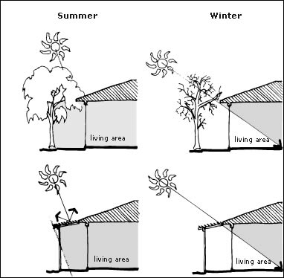
Shading
In general, you'll need some form of shading above doors and windows on the east, north and west side of the house - but the size and type will depend on your circumstances.
Window shading helps to reduce glare and keep indoor temperatures at comfortable levels by minimising the amount of late afternoon sun falling on your windows. Ideally you should not have large areas of western facing glass, but if you already do, then shading these areas (with an awning or deciduous trees) to block out late afternoon sun is a good idea.
Shading options include:
- eaves
- pergolas
- fixed louvres
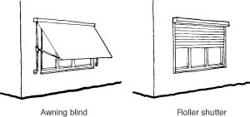
- covered balconies or deep verandas (e.g. a balcony on the north side of your home could block winter sun)
- awnings
- shutters

Source: www.yourhome.gov.au
Curtains and blinds
If you can’t shade from the outside, then the next best option is to install thick lined curtains or blinds – as well as keeping your home warm in winter, they help to stop the sun getting in and overheating your house. In summer, it’s a good idea to adjust the east and west curtains daily to block out unwanted sun. You may want to adjust east-facing curtains to keep out all morning sun but open them in the afternoon to let in some light. You may want to leave west-facing curtains down all day to keep out sun that might otherwise cause overheating.
If you’ll be out all day in summer, it can be a good idea to leave the curtains closed all day.
Creating air movement
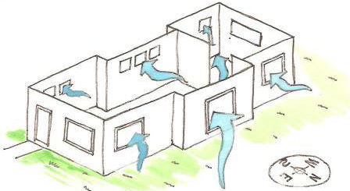
Air movement increases cooling by raising evaporation rates. Passive ventilation is partly about allowing air movement even when the house is closed up, and also about creating that air movement through cross and stack ventilation. Cross ventilation happens when cool air from outside enters a building and forces warm air out through an opening such as a window or door. Stack ventilation happens when inside air warms, rises and escapes through any gaps at the top of the house, drawing in cool air from gaps at the bottom of the house. This pull is called the stack effect because it is the same process that draws smoke up a chimney. Using the stack effect to ventilate homes is the most effective way of keeping a house cool in summer.
Source: www.smarterhomes.co.nz

Design solutions for passive ventilation include:
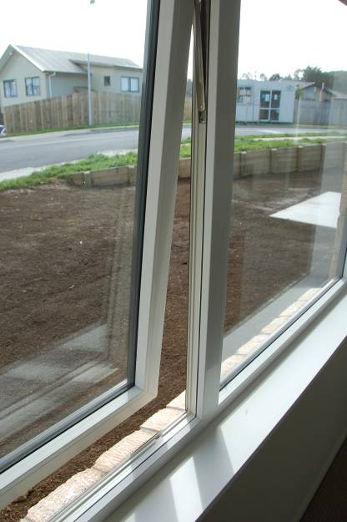
- Small high windows in rooms (e.g. clerestory windows) which can be left open during summer to take advantage of the stack effect. These are particularly useful for night ventilation provided there are also some windows left open in the lower part of the house so cool air is pulled through and hot air expelled.
- Ensuring windows can be opened on all sides of the house and that there are no barriers to airflow within the house. Sometimes this could mean including an air grill above internal doors so that cross ventilation can still occur even if doors are shut. Bedrooms with only one window are frequent victims of overheating –once the bedroom door is shut there is no pressure gradient to pull cool air through the room.
- Use of side opening windows rather than awning opening windows. Side opening windows are much better at pulling breezes into the house.
- In-window passive vent systems. These are secure and can be left open when the house is unoccupied. They include louvres and trickle vents. BRANZ recommends 600mm width of trickle vent for each average sized room.
- Solar or wind powered ventilation systems – these are roof-located ventilation systems which can either run all the time, or be manually controlled. They are best located in a high point in a home, combined with lower opening windows. In most cases, however, the stack effect can be utilised without the need for a special ventilation systems.
One of the most effective ways of cooling your home in summer is to leave windows open overnight. Try and take advantage of the natural draughts flowing through your house – by leaving open internal doors, higher windows, and windows on the opposite sides of the house. Opening windows on opposite sides of the house will also allow you to take advantage of cooling breezes.
When designing a new home or undertaking renovations, include larger windows opening to the breeze and smaller, higher windows on the walls on the opposite side of the house.
In hot climates, it’s also useful to ventilate the roof spaces as otherwise the heat gets trapped in the cavity. Many older homes were designed with roof vents to take advantage of passive stack ventilation and get rid of this hot air.
If you are concerned about security, there are easy-to-install security stays available from your local hardware store.

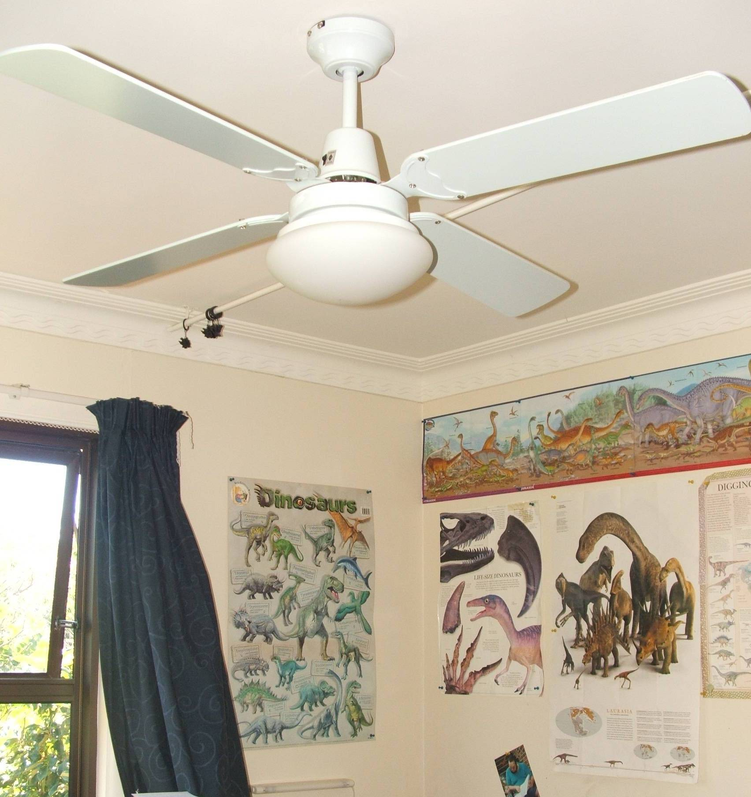
Active cooling
If you still feel that you need to cool your house, then the most energy efficient option is to use fans – either ceiling mounted or portable fans you can move around the house as needed.
If you have a heat pump try not to use it as an air conditioner – but if you do, make sure your doors and windows are closed, and only use it to cool spaces you are using.

For more information:
- See Fact sheets on
  - Passive solar design
  - Managing your indoor temperatures
  - Healthy indoor air
- For more information, visit www.smarterhomes.org.nz/design/passive-cooling/

